Bahria University

Karachi Campus



LAB EXPERIMENT NO.

08

LIST OF TASKS

|  |  |
| --- | --- |
| **TASK NO** | **OBJECTIVE** |
|  | Write a simple stored procedure name **“CustomerRecord”** that returns the desired Customer record from the Northwind database given a parameter of the CustomerID. |
|  | Write a stored procedure name **“Territory”** that accepts a Territory ID, Territory Description, and Region ID and inserts them as new row in the Territories table in Northwind. |
|  |  |
|  |  |

Submitted On:

**24-05-2023**

(Date: DD/MM/YY)

**Task # 01:**

create procedure customerrecord

@customerid nvarchar(30)

as

begin

select * from Customers where @customerid = CustomerID;

end

exec customerrecord arout

**output:**

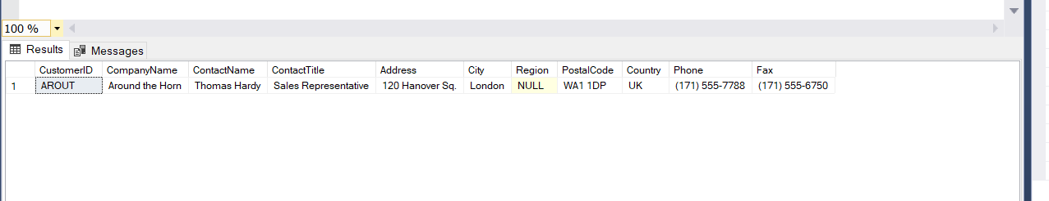

**Task # 02:**

**Solution:**

create procedure territory

@territoryid int,

@territorydesc nvarchar(50),

@regionid int

as

begin

insert into Territories values (@territoryid,@territorydesc,@regionid)

end

exec territory 5003,biryani,2

**Output:**

select * from Territories where TerritoryID=5003

